**Q.1- What is software? What is software Engineering?**

Software: A Program or set of Programs containing instructions which provide desired functionality.

Software Engineering: Software engineering is the art of developing quality software on time and within budget.

**Q.2-Explain Type of software**

There is three group basically in software depending on their uses and application

1. System software/ operating system
2. Application software
3. Programming language

**1.System software**: provides the basic functions for computer usage and helps to run the computer hardware and system.

- System software is the software used by the computer to translate inputs from various sources into a language which a machine can understand.

- Basically, OS coordinates the different hardware components of a computer.

-Ex. Linux, window, macOS, Android, iOS.

**2.Application software**: - Application software is the general designation of computer programs for performing user tasks.

- Types of application software:

1) Mobile app: - Mobile application which is run on mobile - Ex. Instagram, Facebook, etc

2) Desktop app: - it is run stand-alone in a desktop or laptop computer.

- Ex. Microsoft office suite which includes Word, Excel and PowerPoint.

- Ex. Outlook for email, and Firefox, Google Chrome, Mozilla are the web browser.

- Anti-virus is an application and so is the media player.

3) Web application: - web application run on a web browser

- ex. google.com, facebook.com, etc

**3 Programming software**: - programming is the process of designing, writing, testing, debugging, and maintaining the source code of computer programs.

- This software is pawritten in a programming language.

- The purpose of programming is to create a program that exhibits a certain desired behaviour. Ex. c++, html, java, Simlab, php, Python and Visual basic

**Q.3-What is SDLC? Explain each phase of SDLC**

SDLC is a structure imposed on the development of a software product that defines the process for planning, implementation, testing, documentation, deployment, and ongoing maintenance and support. There are a number of different development models

A Software Development Life Cycle is essentially a series of steps, or phases, that provide a model for the development and lifecycle management of an application or piece of software.

SDLC Phases:

1.planning phase: Planning is the phase in which the CRS (customer requirement specification) is studied by engineer and according to it plan is designed for customer.

- in this phase everything is planed like how the product process going on, what kind of model should be generated.

2.Implementation phase: In the implementation phase, the team builds the components either from scratch or by composition.

-Given the architecture document from the design phase and the requirement document from the analysis phase, the team should build exactly what has been requested, though there is still room for innovation and flexibility.

-The implementation phase deals with issues of quality, performance, baselines, libraries, and debugging.

3.Testing phase: Simply stated, quality is very important. Many companies have not learned that quality is important and deliver more claimed functionality but at a lower quality level.

-It is much easier to explain to a customer why there is a missing feature than to explain to a customer why the product lacks quality.

-A customer satisfied with the quality of a product will remain loyal and wait for new Functionality in the next version.

4.Deployment phase: After testing phase the product is delivered to the customer and provide the guide line to use it

5.Maintenance and support phase: Software maintenance is one of the activities in software engineering, and is the process of enhancing and optimizing deployed software (software release), as well as fixing defects.

-Software maintenance is also one of the phases in the System Development Life Cycle (SDLC), as it applies to software development. The maintenance phase is the phase which comes after deployment of the software into the field

-The developing organization or team will have some mechanism to document and track Defects and deficiencies.

**Q-4 What is DFD? Create a DFD diagram on Flipkart**

**Data Flow Diagram (DFD):** DFD is a traditional way to visualize the information flows within a system. A neat and clear DFD can depict a good amount of the system requirements graphically. It can be manual, automated, or a combination of both.

**DFD diagram for Flipkart:**

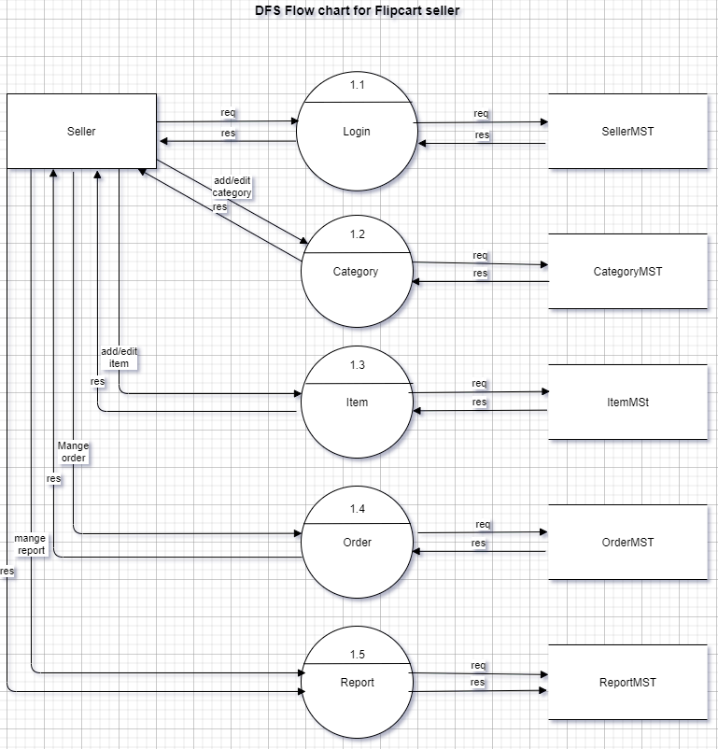

**Q-5 What is Flow chart? Create a flowchart to make addition of two numbers**

**Flow chart:** A flow chart is a graphical or symbolic representation of a process. Each step in the process is represented by a different symbol and contains a short description of the process step. The flow chart symbols are linked together with arrows showing the process flow direction.

**Flowchart for addition of two numbers:**

a=10, b=20, c

C=a+b

**Q-6 What is Use case Diagram? Create a use-case on bill payment on Paytm**

**Use case diagram:** A use case diagram is used to represent the dynamic behaviour of a system. It encapsulates the system's functionality by incorporating use cases, actors, and their relationships. It models the tasks, services, and functions required by a system/subsystem of an application. It depicts the high-level functionality of a system and also tells how the user handles a system.

**Use-case on bill payment on paytm:**

